1. Which apps have the highest rating in the given available dataset?

SELECT App, Rating

FROM playstore_app

WHERE Rating = (Select Max(Rating) From playstore_app);

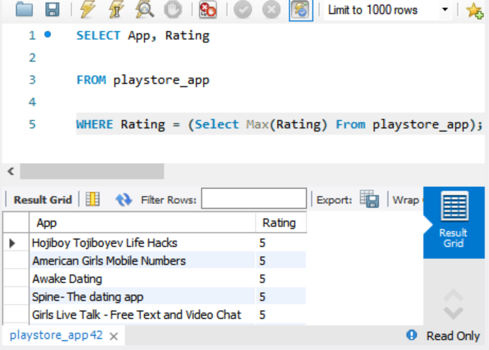

2. What are the number of installs and reviews for the above apps? Return the apps with the highest reviews to the top.

SELECT App, Installs, Reviews

FROM playstore_app

WHERE Rating = (Select Max(Rating) From playstore_app)

ORDER BY reviews DESC;

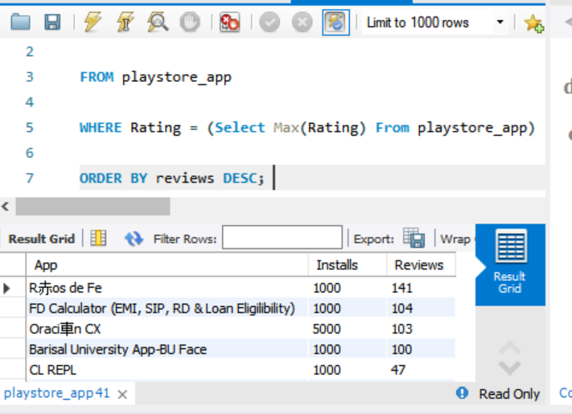

3. Which app has the highest number of reviews? Also, mention the number of reviews and category of the app

SELECT App, Reviews, Category

FROM playstore_app

WHERE Reviews = (Select Max(Reviews) From playstore_app);

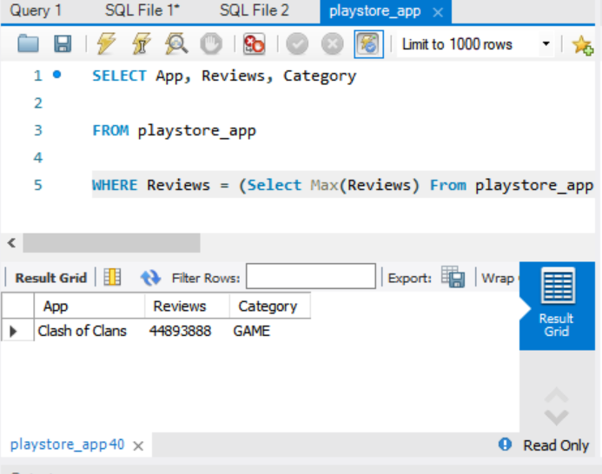

4. What is the total amount of revenue generated by the google play store by hosting apps? (Whenever a user buys apps from the google play store, the amount is considered in the revenue)

SELECT SUM(Price)

FROM playstore_app ;

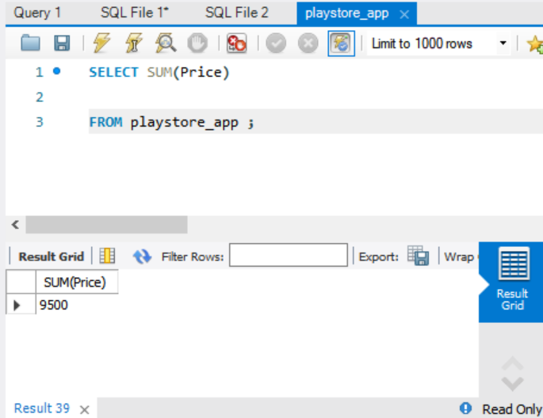

5. Which Category of google play store apps has the highest number of installs? also, find out the total number of installs for that particular category.

WITH Sub AS (SELECT SUM(Installs) As Category_install, category

FROM playstore_app

GROUP BY Category)

SELECT Category_install, category

FROM Sub

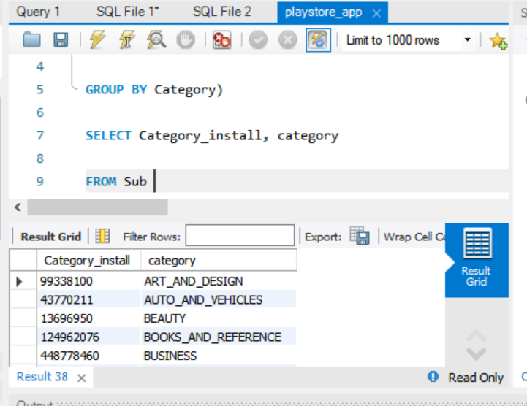

6. Which Genre has the most number of published apps?

WITH sub AS (SELECT Genres, COUNT(Genres) AS total_num

From playstore_app

GROUP BY Genres)

SELECT Genres, total_num

FROM Sub

WHERE total_num= (SELECT Max(total_num) FROM Sub)

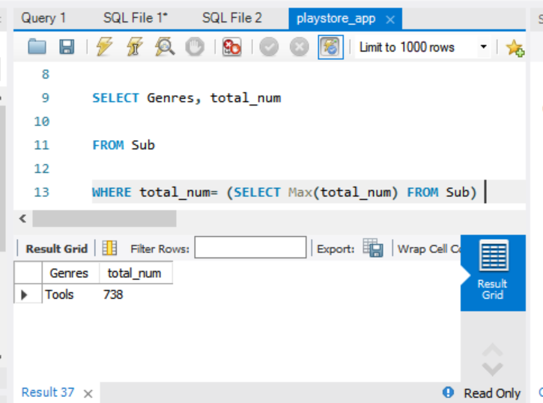

7. Provide the list of all games ordered in such a way that the game that has the highest number of installs is displayed on the top

(to avoid duplicate results use distinct)

SELECT distinct(App), installs

FROM playstore_app

WHERE Category ='game'

ORDER BY Installs DESC

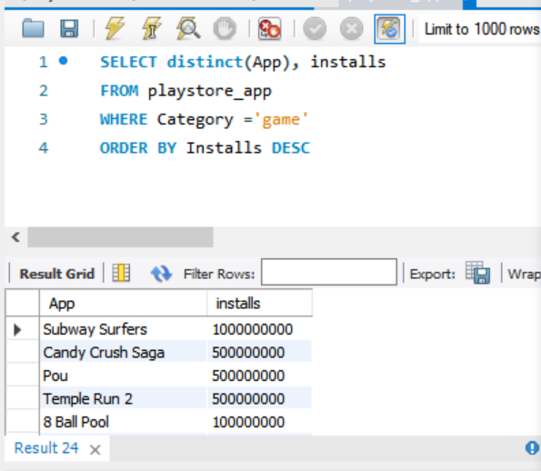

8. Provide the list of apps that can work on android version 4.0.3 and UP.

SELECT App,`Android Ver`

FROM playstore_app

WHERE `Android Ver` in ('4.0 and up','5.0 and up','6.0 and up', '7.0 and up', '8.0 and up')

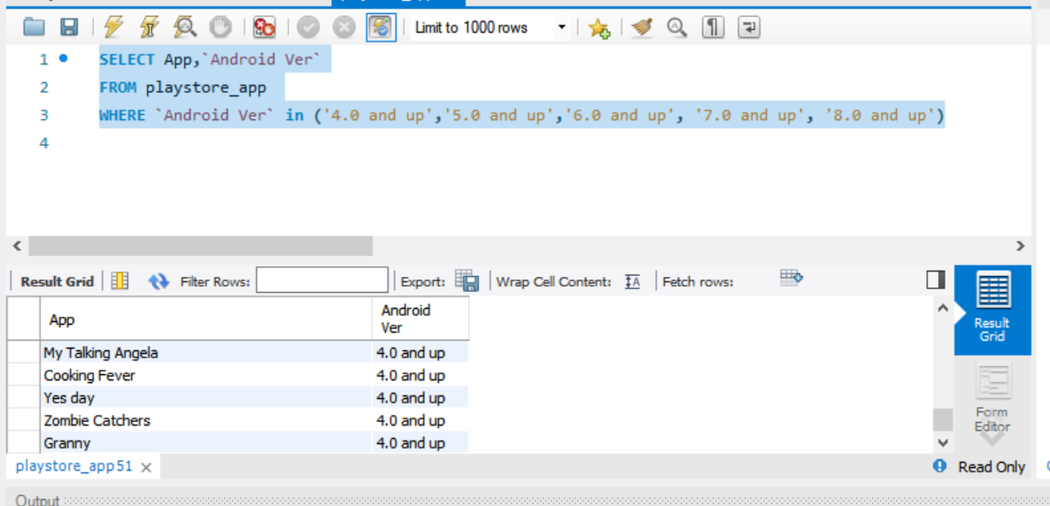

9. How many apps from the given data set are free? Also, provide the number of paid apps.

SELECT

CASE WHEN Price =0 THEN 'Free_app' ELSE 'Paid_app' END AS App_price,

COUNT(app) as numb

FROM playstore_app

GROUP BY CASE WHEN Price =0 THEN 'Free_app' ELSE 'Paid_app' END

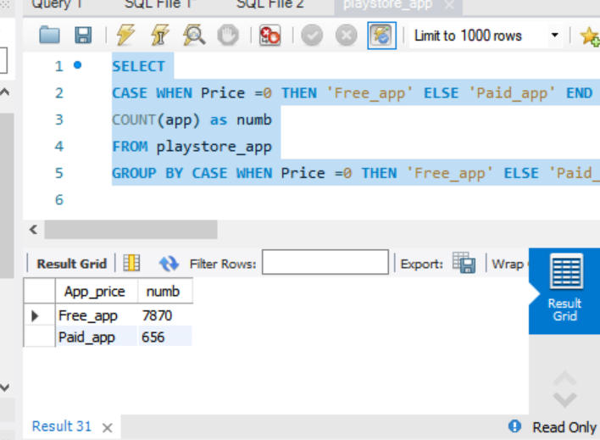

10. Which is the best dating app? (Best dating app is the one having the highest number of Reviews)

WITH sub AS (SELECT *

FROM playstore_app

WHERE Category='DATING')

SELECT App, Category, reviews

FROM sub

Where Reviews= (select max(Reviews) FROM sub)

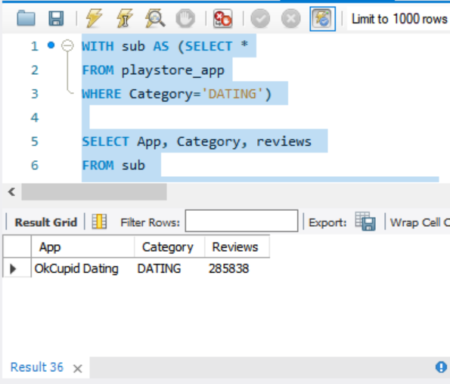

1. Get the number of reviews having positive sentiment and number of reviews having negative sentiment for the app 10 best foods for you and compare them.

SELECT App,Sentiment, count(Sentiment)

FROM playstore_reviews.playstore_reviews

WHERE APP ='10 Best Foods for You'

GROUP BY Sentiment

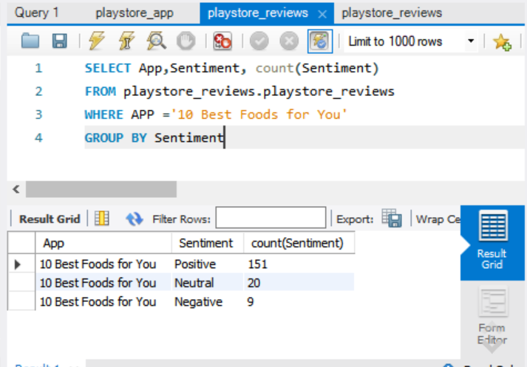

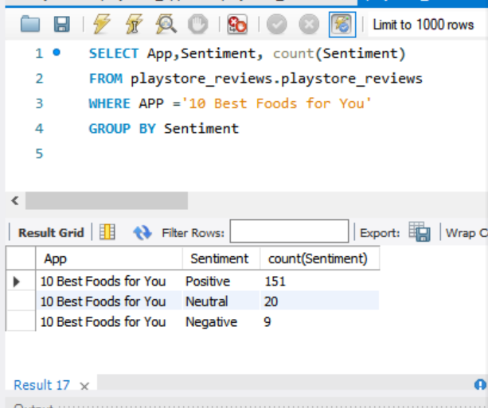

1. Which comments of ASUS SuperNote have sentiment polarity and sentiment subjectivity both as 1?

SELECT Translated_Review

FROM playstore_review

WHERE App='ASUS SuperNote' AND Sentiment_Polatiry=1 AND Sentiment_Subjectivity=1

1. Get all the neutral sentiment reviews for the app Abs Training-Burn belly fat

SELECT Translated_Review

FROM playstore_review

WHERE App='Abs Training-Burn belly fat ' AND Sentiment =’Neutral’

1. Extract all negative sentiment reviews for Adobe Acrobat Reader with their sentiment polarity and sentiment subjectivity

SELECT Translated_Review

FROM playstore_review

WHERE App='Adobe Acrobat Reader 'AND Sentiment ='Negative'